( 2022 )

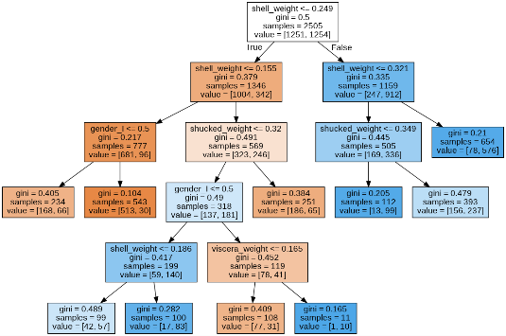

1. Data analysis using abalone dataset

Preprocess the abalone dataset and make decision trees. Find the classification report and Auroc score to find the model’s performance. Find the best parameter to train MLPClassifier and make a confusion matrix.

그외에 (가장 밑에)

여러가지 implimenation들…

Codes available in github…

N-queens problem solver

2. N-queens problem solver

Implied N-queens problem solver using hill climbing, genetic algorithms, simulated annealing, and local beam search. Compare the result between them.

(2021)

3.

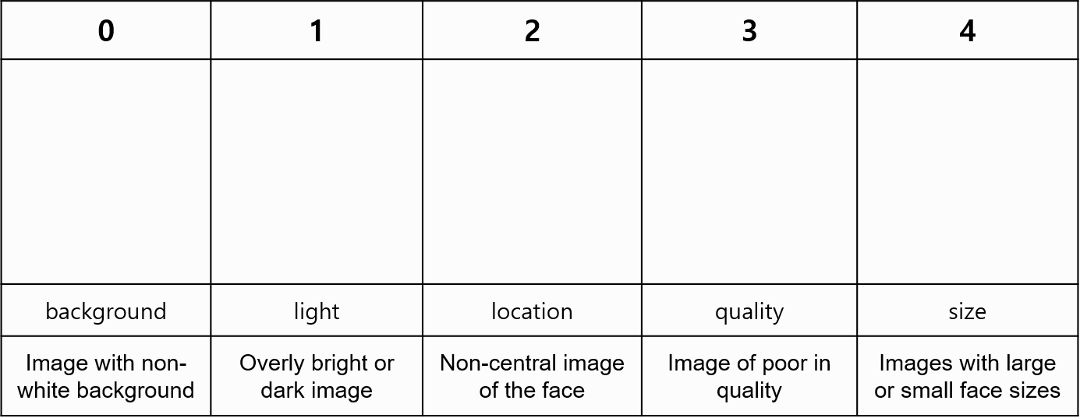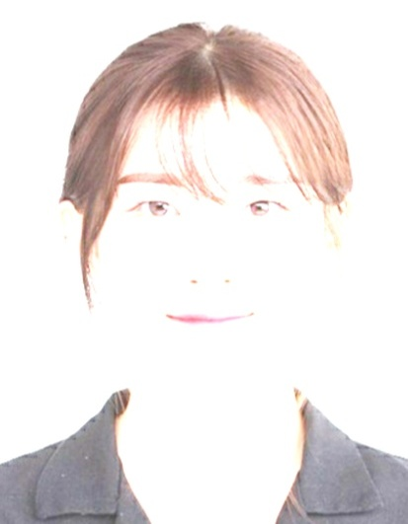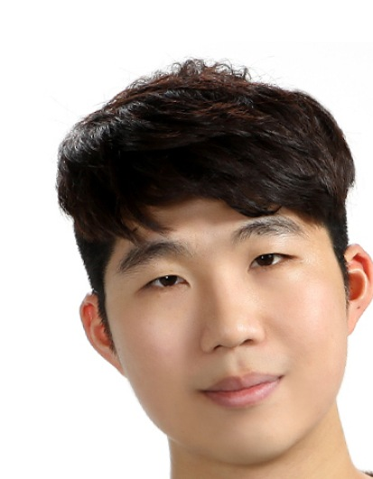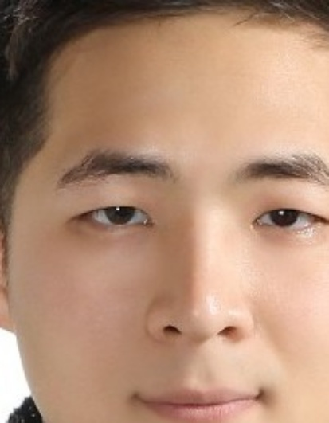

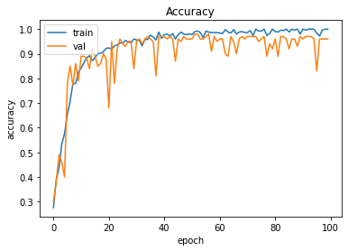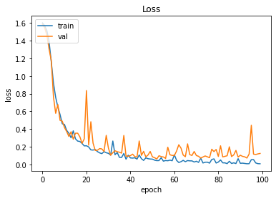

3. Passport Photo Image Multiple Classification Model

Made a photo classifier using a CNN network. It has the function of finding photos that meet the criteria for entering the passport, and the data set was divided into five classification criteria.

4

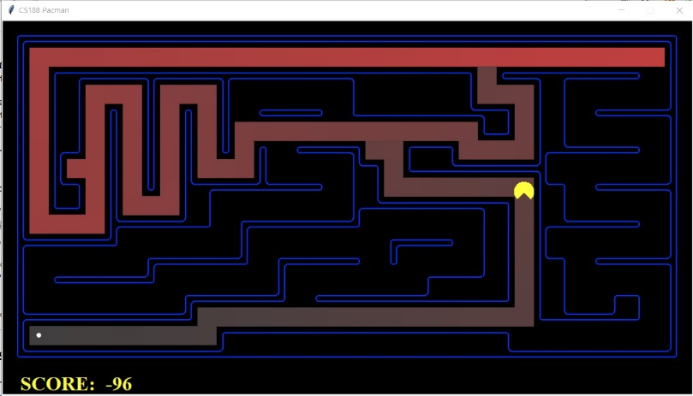

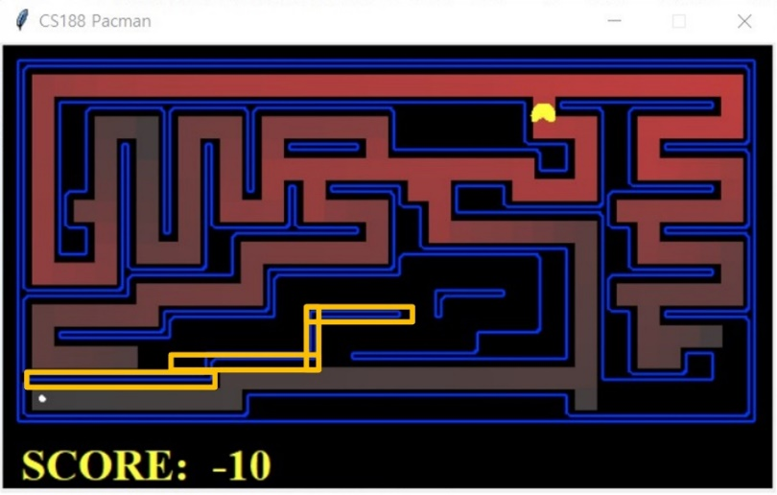

4. The pac-man projects

Made a Pac-man algorithm using many AI concepts like A\* search, probabilistic inference, and reinforcement learning. This project is based on CS188. (the UC Berkeley class)

(2020)

5

영상따로존재

카톡으로 보냄

5’ Cresendo(영상이 이거는 따로 있음)

Created an song recommender application. This application recommends songs that fit the user's desired genre and themes in the selected range.

6. 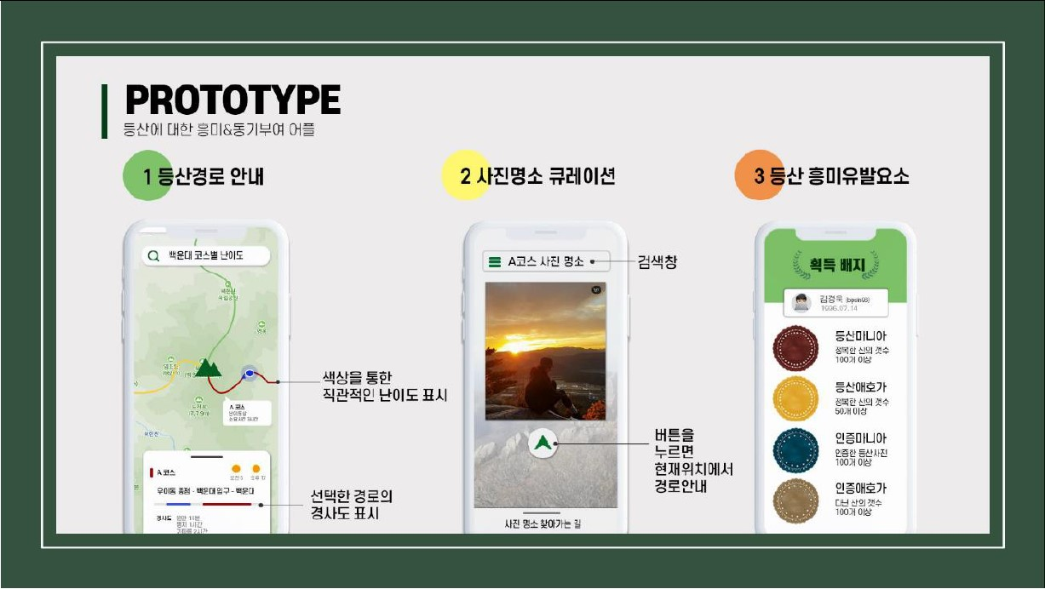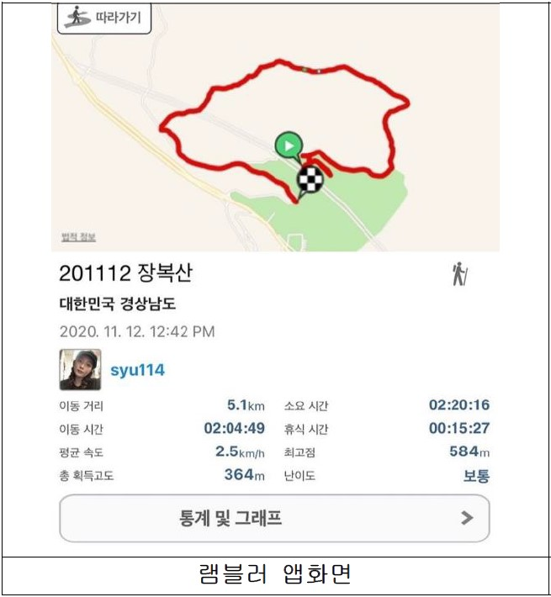

6. Hiking trail decision application

Created an climbing application for young people. This application has a hiking trail recommendation function for young people and a social network function that allows them to share photos of their hiking trails.

7

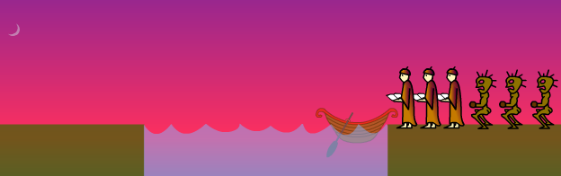

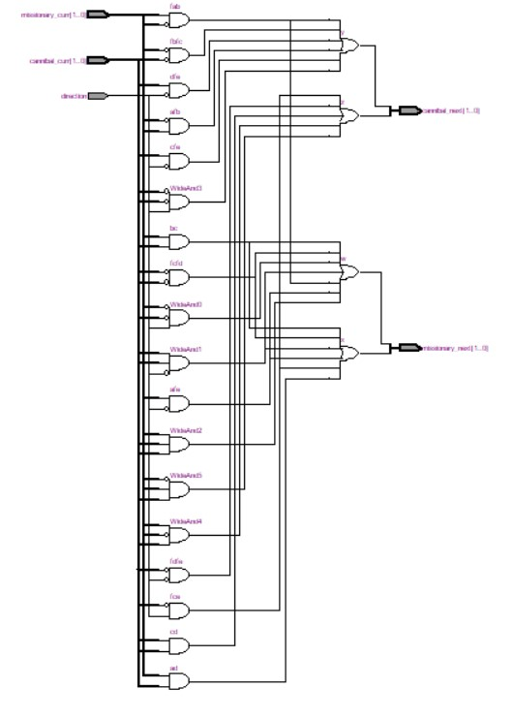

7. Missionaries and cannibals problem

Digital logic design using Verilog HDL for river crossing of 3 missionaries and cannibals.

Visualize logical commands using quartus2 and Altera board.

(2019)

8.  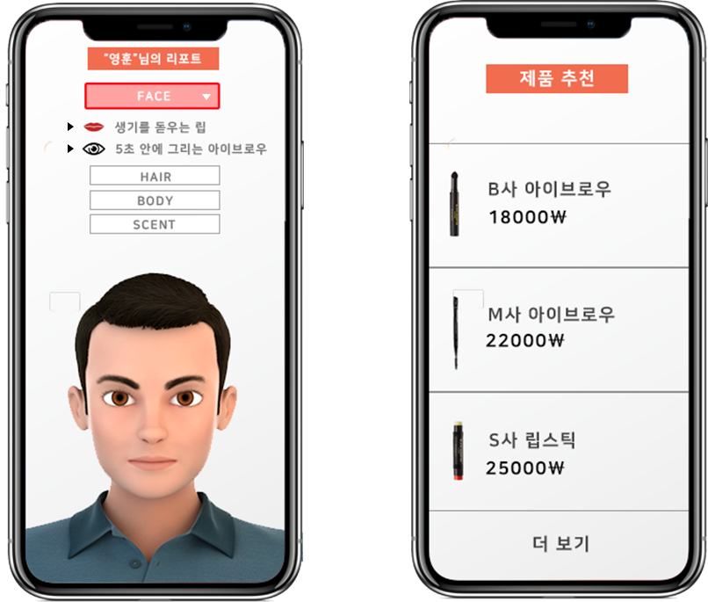

8 Beauty Manside : Application of beauty coordinator for men

We created an application called beauty manside, a male beauty coordinator. This application has made it possible to recommend customized beauty products for men and to make a series of processes available through the application that allow them to purchase them.

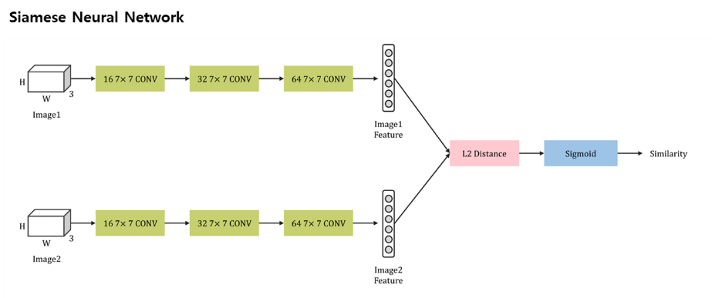

9. Notree : Natural note manufacture vending machine

We invented Notree the natural note manufacture vending machine using a siamese neural network to divide new papers. Notree accepts old notes and reuses the paper which is unscribbled using Siamese neural network.